**INSTALLING**

1. Run Anaconda Command Prompt as Administrator
2. To start MLFlow, run following commands:

* conda install -c conda-forge mlflow
* conda install -c conda-forge/label/broken mlflow
* conda install -c conda-forge/label/cf202003 mlflow

1. In Jupyter Notebook import all the necessary libraries, data set and perform all the desired task
2. Login to Azure account
3. Start your Virtual machine and click to connect.
4. Download the remote desktop connection and click on run
5. Follow the instructions and click to connect to the VM machine.

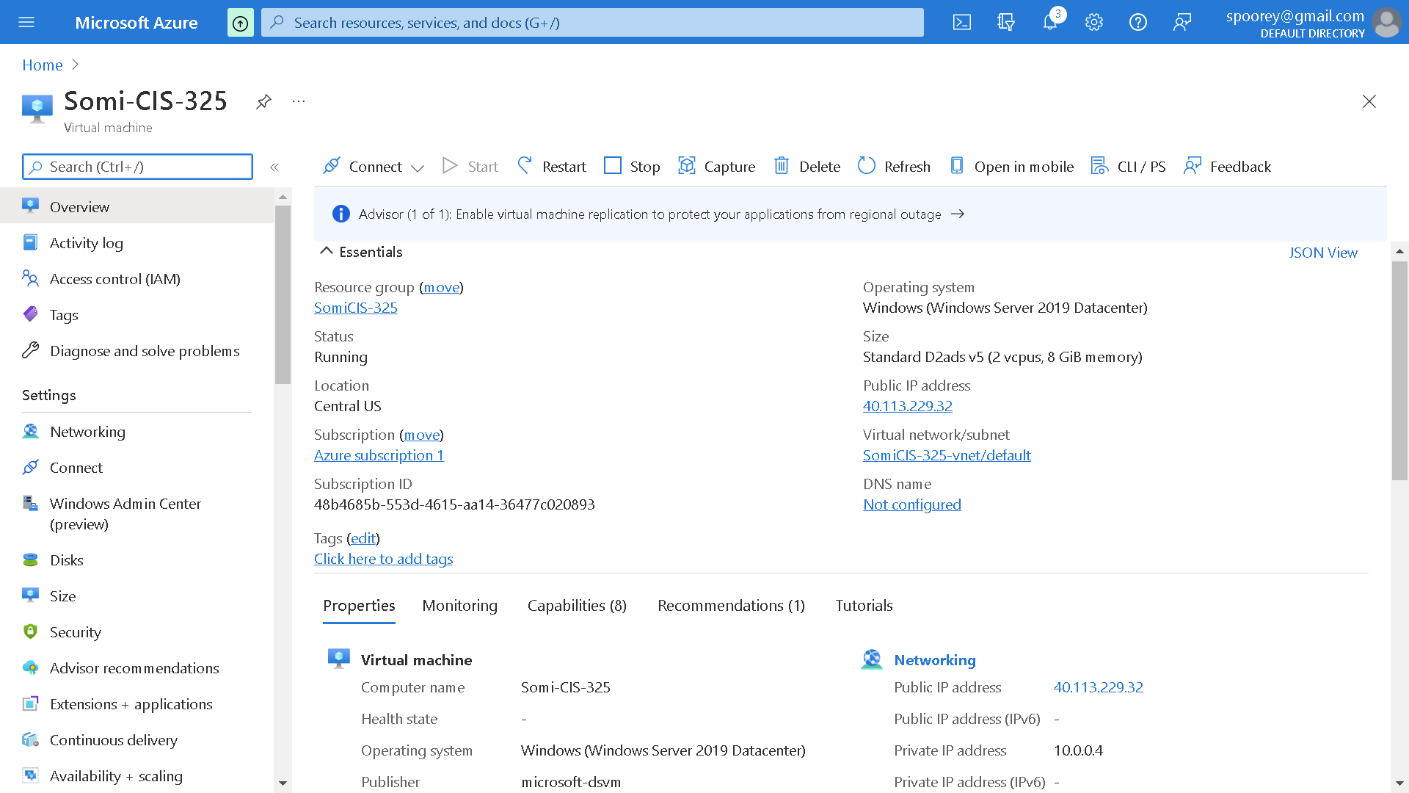

1. If you fail to connect, make sure you are entering the right set of credentials while logging in. It is same when we created the account on Azure.
2. Once you are logged in, the system will take some time to setup.
3. After set-up is done, log in to your virtual machine to make sure everything is working
4. If you are using Jupyter notebook, make sure to open the jupyter notebook and let it setup
5. Now download the dataset, your previously created jupyter notebook into the virtual machine.

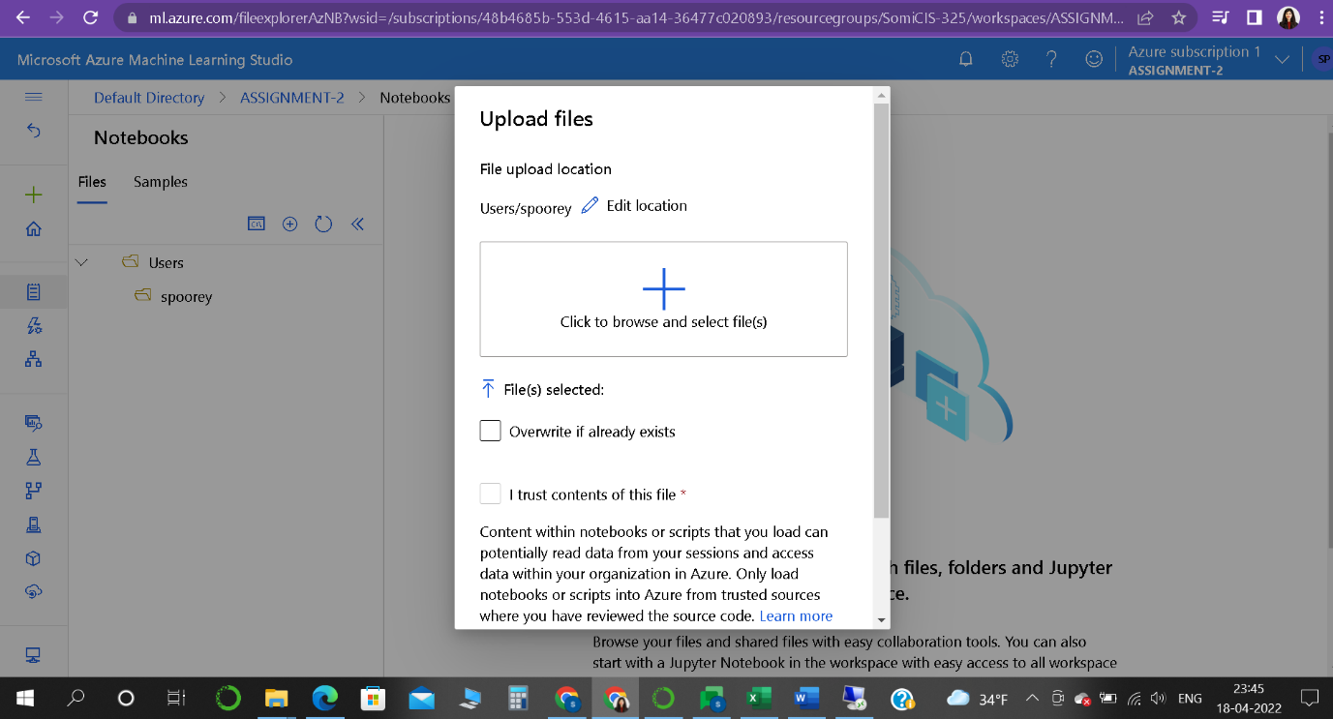

**Issue:**

Creating Instance took a whole lot of time and I was not able to select a quota, and it was not moving forward. (Processor was not able to connect, may be because I was not using Student Account)

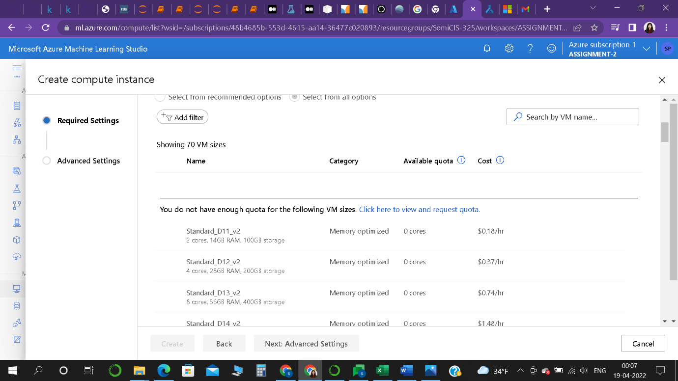

So, I shifted from Azure to AWS Sage maker

